A000-Xian-Egypt-Coptic-Crosses-4th c CE

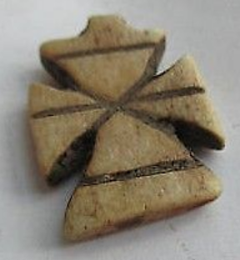 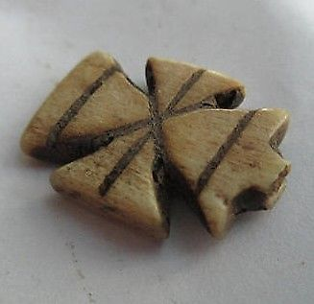

Authentic Ancient Egypt Coptic Bone Cross

The oldest cross type. $150

**Case No.: 4**

**Accession No.**

**Formal Label:**

**Display Description:**

Roman Egypt, c. 4th Century CE. Gorgeous Coptic wood cross pendant. Egyptian Early versions of the Coptic cross was a fusion of the Orthodox Christian cross and pagan Egyptian ankh. The Orthodox cross has three cross beams, one for arms, a second, sloped one for the feet, and a third at the time for the INRI label placed above Jesus's head.

Well carved. Light brown patina

**Accession Number:**

**LC Classification:**

**Date or Time Horizon:**

**Geographical Area:**

**Map:**

**GPS coordinates:**

**Cultural Affiliation:** Coptic Christian

**Media:**

**Dimensions:** H 20 mm

**Weight:**

**Condition:**

**Provenance:** Ex H. Sakr collection, London, acquired 1960's.

**Discussion:**

The Coptic Church was established by Saint Mark in the first or third year of the reign of Emperor Claudius, i.e. 41 or 43 CE, according to Eusebius of Caesarea (260/265 – 339/340 CE) in his *Ecclesiastical History*. These crosses represent the very first attempt to symbolize Jesus as an iconic divine being, i.e. refusing to portray him as a human figure. This may reflect the Coptic Church’s opposition to the Arian party that regarded Jesus as a purely human prophet.

These crosses made of olive tree wood are carved in three registers: an upper register representing the head of the savior, a middle register representing his body, and a lower, downward slanting register his feet. The plinth at the bottom represents the lower part of the Egyptian ankh which forms its “handle”.

These crosses date to a time no earlier than the Council of Nicaea, 325 CE, when the earliest crosses have been dated in controlled excavations and when the concept of a resurrected human-divinity was established theologically by the Nicene Creed under the guidance of Constantine. The elevation of Jesus to this position of divinity reflected Constantine’s effort to achieve a religion that would surpass all of the other so-called “pagan” cults in its ineffability. Politically this reflected Constantine’s effort to solidify the two halves of his empire, western Roman Latin and Eastern Hellenistic Greek. Economically this reflected Constantine’s effort to gain control of all the monetary and real estate holding of the traditional cults in order to be able to continue to fund his armies and the hitherto health, education and welfare duties of the Roman Empire both East and West.

As a consequence, in Egypt, Christian teaching emphasized the divine nature of Jesus which was easily understood by the local Egyptian (as opposed to a Greek or Roman) audience that traditionally had a pantheon of deities they worshipped. The equi-armed cross symbol and the lower plinth were regarded by them as a fusion of the ancient Egyptian ankh plinth and the Coptic Christian equi-armed cross symbol which resulted in a autochthonous unique Egyptian-Ankh-Cross.

**References:**

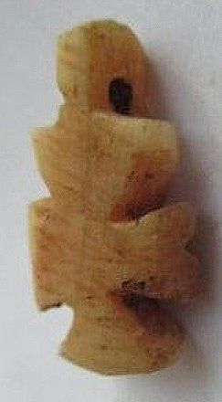

Ancient Egyptian Coptic Wood Cross wooden

Roman Egypt, c. 4th Century CE. Gorgeous Coptic wood cross pendant. Egyptian Early versions of the Coptic cross was a fusion of the Orthodox Christian cross and pagan Egyptian ankh. The Orthodox cross has three cross beams, one for arms, a second, sloped one for the feet, and a third at the time for the INRI label placed above Jesus's head.

Well carved with suspension loop at top. Brown patina. C 20 mm Ex H. Sakr collection, London, acquired 1960's. The oldest cross type. $150

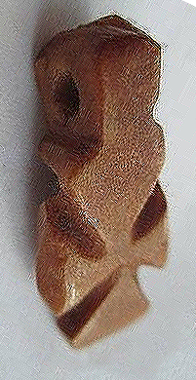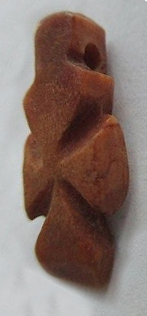

Ancient Egyptian Coptic Wood Cross

Roman Egypt, c. 4th Century CE. Very early Coptic wood cross pendant. Early versions of the Coptic cross was a fusion of the Orthodox Christian cross and pagan Egyptian ankh. Well-carved with suspension loop at top. Brown patina. C 20 mm Ex H. Sakr collection, London, acquired 1960's. The oldest cross type. $150